РТ7

1.1

| Шаг | 1 | 2 | Вывод |
| --- | --- | --- | --- |
| A | A = 0 | - | 0 |
| B | B = 0 | B := A (0) | 0 |
| C | C = 5 | C := B (0) | 0 |
| D | D = 10 | D := C (5) | 5 |

| Шаг | 1 | 2 | Вывод |
| --- | --- | --- | --- |
| A | A = 0 | - | 0 |
| B | B = 5 | B = A (0) | 0 |
| C | C = 0 | C = B (5) | 5 |
| D | D = 10 | D = C (0) | 0 |

| Шаг | 1 | 2 | Вывод |
| --- | --- | --- | --- |
| A | A = 10 | - | 10 |
| B | B = 20 | B := A (10) | 10 |
| C | C = 6 | C := B (20) | 20 |
| D | D = 4 | D := C (6) | 6 |

1.2

| Операция | Результат |
| --- | --- |
| Ввод S | S = 2.09 |
| S1 := 0; N := 0 | S1 = 0; N = 0 |
| Н. Ц. S1 < S | 0 < 2.09 → YES |
| N := N + 1 | N = 0 + 1 = 1 |
| S1 := S1 + 1 / N | S1 = 0 + 1 / 1 = 1 |
| П. Ц. S1 < S | 1 < 2.09 → YES |
| N := N + 1 | N = 1 + 1 = 2 |
| S1 := S1 + 1 / N | S1 = 1 + 1 / 2 = 1.5 |
| П. Ц. S1 < S | 1.5 < 2.09 → YES |
| N := N + 1 | N = 2 + 1 = 3 |
| S1 := S1 + 1 / N | S1 = 1.5 + 1 / 3 = 1.83 |
| П. Ц. S1 < S | 1.83 < 2.09 → YES |
| N := N + 1 | N = 3 + 1 = 4 |
| S1 := S1 + 1 / N | S1 = 1.83 + 1 / 4 = 2.08 |
| П. Ц. S1 < S | 2.08 < 2.09 → YES |
| N := N + 1 | N = 4 + 1 = 5 |
| S1 := S1 + 1 / N | S1 = 2.08 + 1 / 5 = 2.28 |
| К. Ц. S1 < S | 2.28 < 2.09 → NO |
| Вывод N | 5 |

2.3

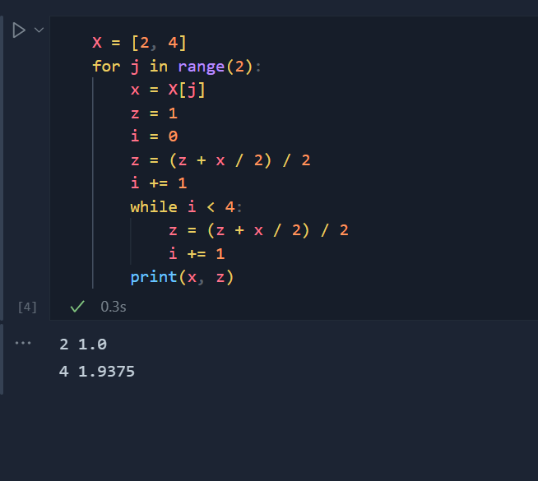

2.1

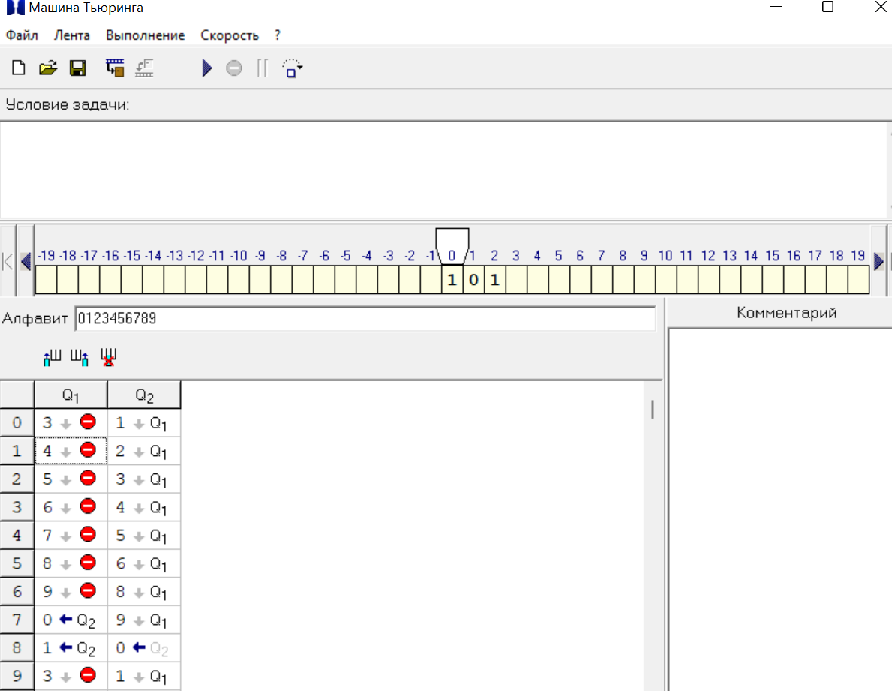

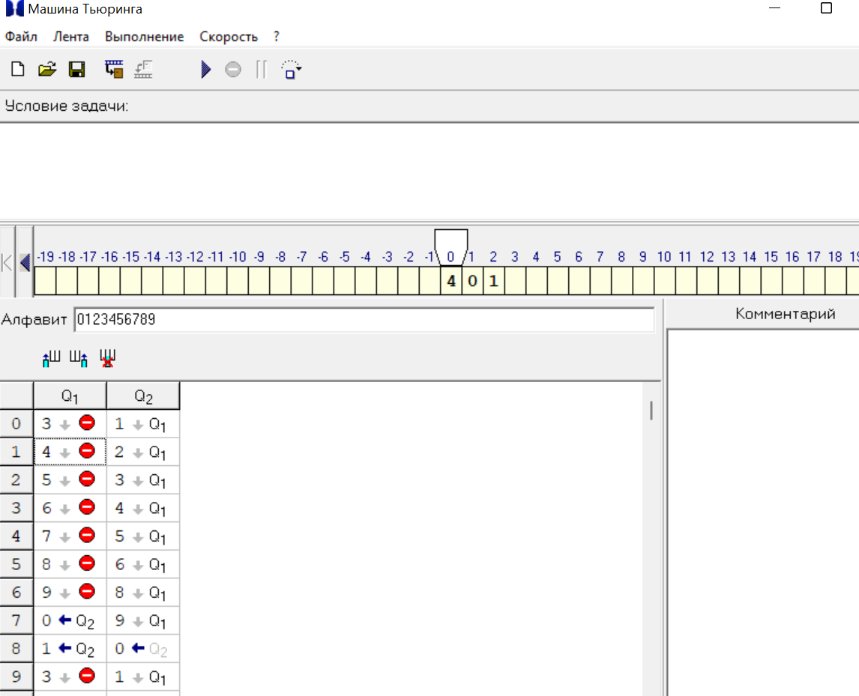

2.2

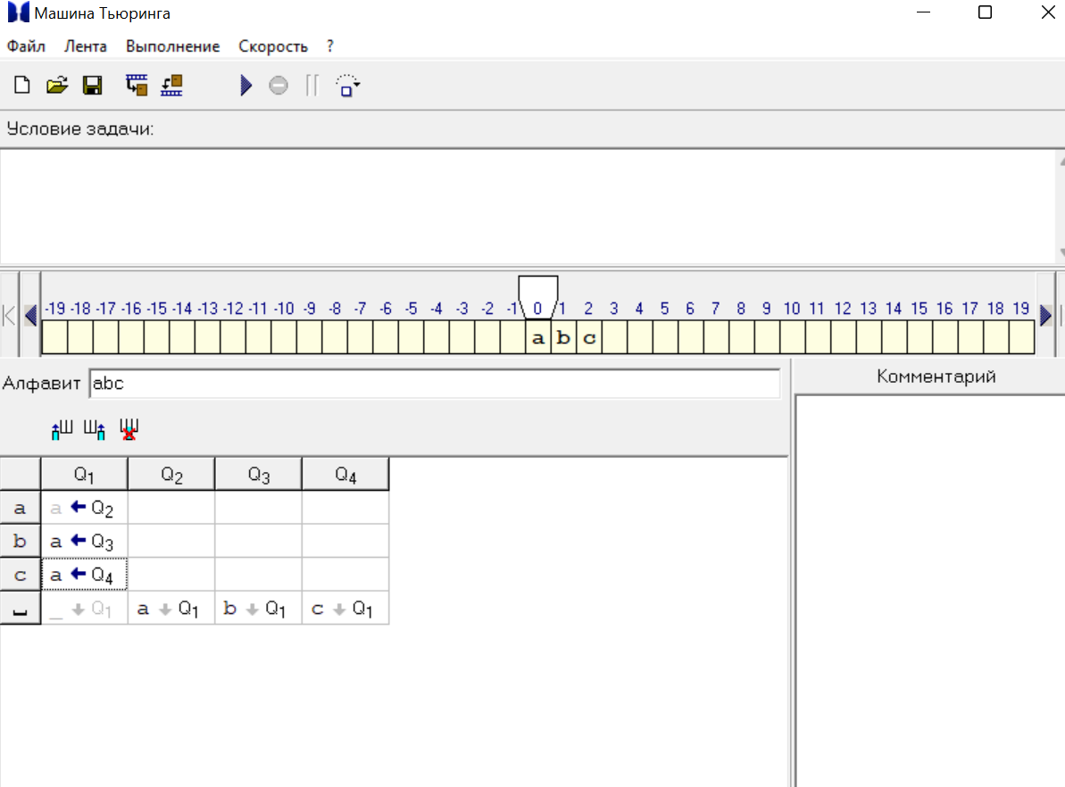

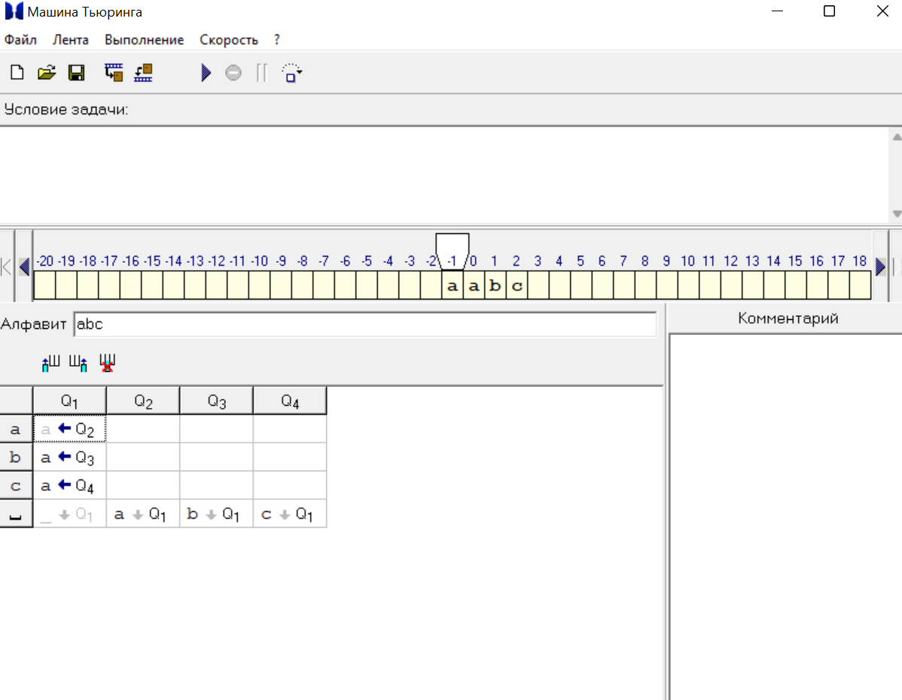

2.3

